EDUC 6201

Handbook on promoting a Positive Learning Environment

Agnieszka Becek

May 2010

Introduction
Teacher’s job is not merely teaching curriculum content. Some might be surprised, even shocked and that is why they have left the profession by now. Some did not (sadly for students) and struggle by fighting with students or by giving up any hope.
What is teacher’s job?
It is managing a group of disparate individuals in a way that quality learning can take place- creating safe and comfortable environment; structure the learning experiences to take students purposefully towards important, meaningful long- term goals; create learning experiences that are interesting, challenging and realistic; value student’s efforts; help them to see the importance of this effort in successful learning; trust students; allow them to fully participate in their learning process…(Killen, 2006). The list goes on. In this meaningful and complex process all teachers expect their students to show positive attitudes, humane behavior, self- direction, initiative, strong effort to learn and personal responsibility (Charles, 2002). Those perfect conditions in which quality learning takes place is called a positive learning environment.
Why is it so important to create a positive learning environment in schools?
As the research shows, and every teacher will agree, positive learning environment maximizes the learning of every student. It helps students become full participating citizens of society to build a sense of community.
How to create a positive learning environment in a class?
Many strategies have been suggested. Adequate curriculum and teaching methods are major factors that help to accomplish this goal, but another key aspect is a discipline system (Charles, 2002).
This handbook will focus on behavior management techniques that intend to help both teachers and students (in a more indirect way). It is design to act as a practical resource to any teacher who wishes to create and/ or improve a positive learning environment in his/ her class. It will summarize three main strategies that can be implemented as part of the classroom management plan. Those strategies are: Preventive, Supportive and Corrective actions.
Choosing a right Strategy
Students behave in ways which are meaningful and purposeful, based on their perceptions of the best ways to meet their particular needs in a situation or context (DECS, 2010). Maria Montessori believed that children are not naughty by nature and they misbehaviors are merely their reactions to an environment that has become inadequate. It is understood that the child must do what adults tell him, even though his environment no longer suits his needs (Montessori in NAMC, 2007).
The pyramid table shown above is a helpful reference for any teacher and parent. A study of it together with careful insight into student’s behavior, circumstances, etc can be very beneficial in determining the best approach to each individual student.

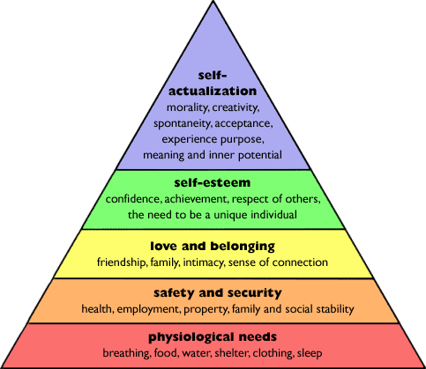
Figure 1 Maslow’s Hierarchy of needs
Source: http://bit.ly/f3KQ2
Preventive Discipline
The discipline aims to find means of misbehavior before it happens and to lessen the need for use of more intrusive management techniques (Levin & Nolan, 2003, p.25). Kounin suggested that “good classroom behaviour depends on effective lesson management, especially on pacing, transitions, alerting, and individual accountability” (Teacher Matters, Kounin, 2008). He expanded that in his model where he stated that:
- Teachers should know what is happening in all parts of the classroom at all times (he called this awareness, 'with-it-ness').
- The ability to provide smooth transitions between activities and to maintain consistent momentum within activities is crucial to effective group management.
- Teachers should strive to maintain group alertness and to hold every group member accountable for the content of a lesson, which allows optimal learning to occur.
- Student satiation (boredom) can be avoided by providing a feeling of progress and by adding variety to curriculum and classroom environment.
Strategies to use:
- Treat students sensitively, giving them a sense of hope, security, acceptance, dignity
- Build a sense of mutual respect
- Try to build a relationship with students
- Use routines and procedures
- Provide interesting curriculum, activities, variety of enjoyable and worthwhile topics that will engage students
- Use helpful Teaching Style to suit students’ Learning Styles
According to Kounin, “by keeping students busily (and happily) engaged, behaviour problems are reduced to a minimum” (Teacher Matters, Kounin, 2008).

Advantages | Remember
- The discipline can prevent most (research shows 97%) major behavior issues. | - Use variety of activities  - Keep in mind different Learning Styles of your students  - Be enthusiastic.  - “It is better to prevent than cure”

Supportive Discipline
Despite teachers’ best efforts, students do sometimes become restive and can start to misbehave (Charles, 2002). When there is a substantial violation of rules or disruption in the class, Supportive discipline should take action. Levin and Nolan (2003) believe that students must learn to control their own behavior and therefore, the initial interventions are subtle, nonintrusive and very student centered, but as the misbehaviors escalate, the interventions take more teacher centered while teacher takes more responsibility (see Figure 2).
Strategies to use:
- Apply positive/ negative consequences
- Skinner’s Model (Positive reinforcement)
  - Social (words, gestures, and facial expressions- smile, etc).
  - Graphic (marks of various kinds such as numerals, checks, happy faces, and special symbols)
  - Activity (activities that students prefer in school. Any activity can be used as a reinforcer if students prefer it to another: game, free reading, extra recess time, special project, etc)
  - Tangible (real objects that students can earn as rewards for desired behaviour and are more powerful for some students than other types of reinforcers)
- Glasser’s Supportive strategies:
  - Develop classroom goals
  - Clear classroom rules
  - Achieve commitment for goals, rules and procedures decided on
  - Decide on consequences (as a group)
- Apply sanctions (e.g. ABC)
- Detention
- Exclusion
- Suspension
It is important that parents are always fully informed of the rules, procedures of enforcement and consequences that exist in the class, so they can be supportive in the process (Charles, 2002).
- Non-verbal skills (Levin & Nolan, 2003, p.28):
  - Planned ignoring
  - Signal interference
  - Proximity interference
  - Touch interference
- Hints and suggestions
- Light challenges (to refocus students)
- Zone of Proximal Development (ZPD) modification
Advantages | Remember
- Low level intervention and non-verbal cues are likely to resolve the issue without disruption to either teaching or learning process.  - Fast and low- confrontational way of re-directing students towards on- task behavior.  - Can be very powerful in supporting students in making intelligent choices.  - Provide with the opportunity for student to control his/her own behavior (Levin & Nolan, 2003, p.27).  - A number of interventions is still preserved (Levin & Nolan, 2003, p.31). | - If overused students might start to associate staying on-task with rewarding, and will only do so if given a positive consequence.  - Early interventions should not force students, but rather influence them to manage themselves (Levin & Nolan, 2003, p.27).  - Interventions should protect students from physical and psychological harm (Levin & Nolan, 2003, p.28).  - Systematic attention and reinforcement can be very powerful.  - Show interest in students’ work.

Corrective Discipline
The last of the three major categories is a Corrective discipline. It is often implemented into the class management plan, where mild interventions did not help in resolving the issues and were allowed to escalate. Although, the strategies used within this discipline are for some teachers consider extreme, Charles (2002) is confident that even then teacher can still help students to return to proper behaviour without “ill feelings”. This can be achieved by:
- Intervening in a positive manner
- Talking to student in a respectful way
- Remaining pleasant and retaining composure
- Refusing to argue
- Applying plan consistently
- Not humiliating student
Strategies to use:
- Hints: Peer Reinforcement
- Direct appeals
- Reminders
- Humour
- Glasser’s triplets (ask student three questions: 1) What are you doing? 2) Is it against the rules? 3) What should you be doing?)
- Gordon’s “I- message”
- Canter’s Broken Record (clearly communicating to a student that the teacher will not engage in verbal bantering)
- Use of logical consequence
- Glasser’s Choice Theory (The only persons’ behaviour I can control is my own)
- Glasser’s Reality Therapy (Focusing on present behaviour and whether it takes student where desired).
Kounin noticed that when teachers correct misbehaviours in one student, it often influences the behaviour of nearby students. This is known as the ripple effect (Teacher Matters, Kounin, 2008).
Advantages | Remember
- Possibility to address the situation and the misbehavior rather that picking on individual student.  - The ripple effect.  - Broken record is very effective in avoiding verbal battles with students (Levin & Nolan, 2003, p.41). | - Some ineffective verbal interventions might encourage inappropriate behavior while some might give abstract, meaningless directions or predictions (Levin & Nolan, 2003, p.33).  - Do not turn humor into sarcasm which is directed at or makes fun of student (Levin & Nolan, 2003, p.37)  - Avoid open- ended questions which result in dishonest, improper or unexpected responses from students (Levin & Nolan, 2003, p.40).  - Apply logical consequence calmly and thoughtfully, avoiding punitive manner (Levin & Nolan, 2003, p.42).  - Never shout at student (Cowley, 2006, p.39).  - Use supportive language, in a firm uncompromising tone

Conclusion
The strategies to use within each discipline can be summarized in a graph of Hierarchy of Management Intervention.
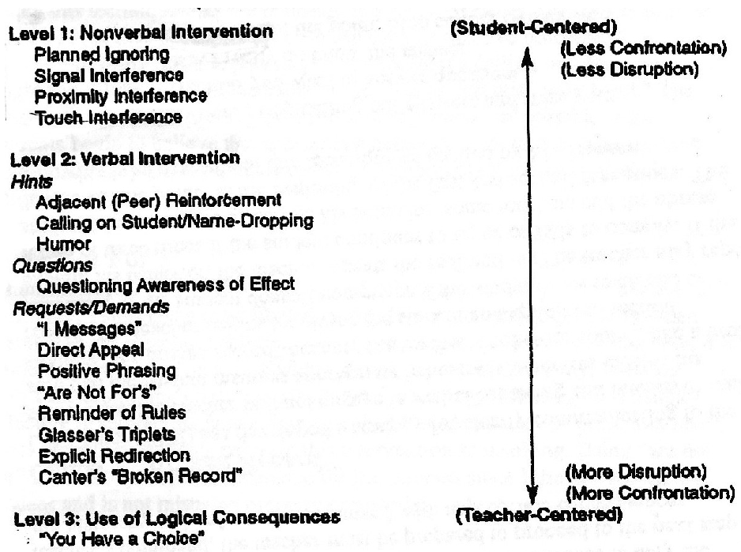
Figure 2 Hierarchy of Management Intervention
Source: Levin & Nolan, 2003, p.43

The key element in creating a positive learning environment is the individual interaction with every student and making them feel special. This leads to building a relationship with students which is based on trust, respect and recognizing true values (of both students and teachers). We must not forget that “[…] children think in ways that are qualitatively different from the ways adults think” (Piaget in Krause et al, 2003) and through their continuous cognitive development those values change and shape at all times.
As mentioned before, students tend to respond to situation in way they think is best at the time (DECS, 2007). Most misbehaviour results from their attempts to get some kind of recognition from the teachers and others. When frustrated in their attempts to gain what they desire, their behaviour turns towards "mistaken goals" (Teacher Matters, 2008). It is teacher’s responsibility to get to know students’ backgrounds and current situation. This will help to apply appropriate strategy in re-directing student into a desired positive behavior. Dreiker’s stressed the importance of recognition the purpose of discipline: “[it] is not a punishment. It is teaching students to impose limits on themselves” (Teacher Matters, Dreiker, 2008). Skinner agrees: “people can have mental control over their responses” (Teacher Matters, Skinner, 2008).
Teacher needs to carefully think about introduction and implementation of techniques of any discipline (Charles, 2002, p. 250). All have to be considered: expected behavior, class rules, teachers and students’ preferences and teacher’s instructions, potential disagreement and the ways to approach compromise, etc.
It is worth remembered that no matter how much we try, no one can control other’s behavior. No teacher can control student’s behavior; rather she/he can only influence it and shape it in some ways. Planning and preparation are the most important in that influencing.
As a teacher you can influence your students’ behavior but you cannot control it – you can only control your own (Matthews, 2010). “You can only be held responsible for controlling her own behavior in such a way that it increases the likelihood that the students will learn and want to behave appropriately (Levin & Nolan, 2004, p.197).
Just like the common saying goes: “If you want to change the world- start from yourself”…
References:

Charles, CM 2002, Building Classroom Discipline 7th Edition, Pearson Education, New Jersey

Cowley, S 2006, Getting the Buggers to Behave, Continuum

Department of Education and Children’s Services, 2007, ‘School Discipline’ in Policy Statement

Levin, J & Nolan, F 2003, What every teacher should know about classroom management. Pearson Education.

Killen, R 2006, Effective Teaching Strategies: Lessons from Research and Practice 4th Edition, Thomson, Social Science press

Krause, K, Bochner, S, Duchesne, S, 2003, Piaget’s theory on Cognitive Development in Educational Psychology for Learning and Teaching, Thomson

Matthews, R, 2010, Chronic Behaviour, Lecture/ Class, The Adelaide University, unpublished

North American Montessori Centre (NOMC) ,2007, Montessori Classroom Management in Montessori Teacher Training viewed on 4 May, 2010: http://montessoritraining.blogspot.com/2007/09/montessori-classroom-management.html

Teacher Matters 2008, ‘The Kounin Model’, in Teacher Matters, viewed 3 May 2010: http://www.teachermatters.com/index.php?option=com_content&view=article&id=9:kounin-model&catid=4:models-of-discipline&Itemid=4

Teacher Matters 2008, ‘The Skinner’s Model’, in Teacher Matters, viewed 3 May 2010: http://www.teachermatters.com/index.php?option=com_content&view=article&id=9:kounin-model&catid=4:models-of-discipline&Itemid=4

Teacher Matters 2008, ‘The Kounin Model’, in Teacher Matters, viewed 3 May 2010: http://www.teachermatters.com/index.php?option=com_content&view=article&id=9:kounin-model&catid=4:models-of-discipline&Itemid=4
Note:
Parts: “Strategies to use”, “Advantages” and “Remember” described in this Handbook are based on Matthews, R, 2010, Lecture/ Class slides or notes, The Adelaide University, unpublished unless referenced otherwise.

